

**Blood bank samples for Crossmatch and Group and Hold – Labelling of tubes**

**Blood tubes and request forms that do not comply with POL0012, and those with patient labels will be rejected and a repeat specimen required**

|  |  |  |
| --- | --- | --- |
|  | Surname | Ward |
| Forename *(First name)* | Sex M/F |
| Addressing/NHS No*. (if no UR number)* | DOB |
| Hospital No. *(UR number)* | Date |
| SIG. *(Signature or initials)* | Time |

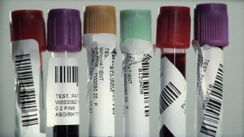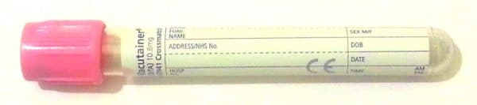

**All tubes must be handwritten with the following details.**

Insert clinical notes here

***Signature or initials must match the blood tube****.*

BD Vacutainer

*Signed declaration.****Signature must match that on the blood tube****.*